**Scale Middleware (PLS110-SF)**

**Version 1.0**

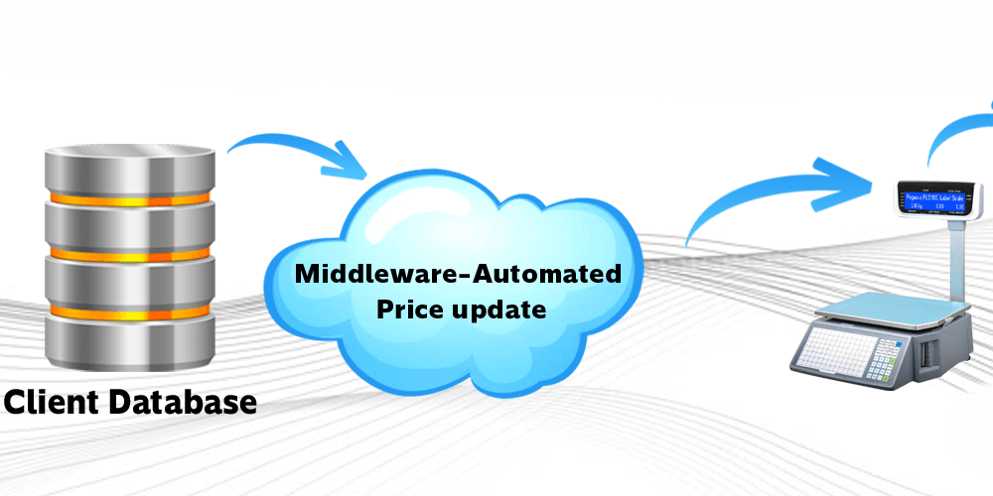

**INDEX**

Contents

Registration 2

Setup Installation 2

License Activation 8

Main Screen and Options 10

Company Master 11

Device Master 12

Database Setup 13

PLU Master 16

Scale Utility 17

License Info 20

# Registration

1. **Following steps to register and configure app**.
   1. You must register at [www.PegasusTech.net](http://www.PegasusTech.net) as customer. So create your account on site.
   2. Once login then visit following address and buy app.
   3. Pegasus PLS1100 hardware only support for this app.

<https://www.pegasustech.net/products/pegasus-softwares/scale-label-kuwait>

# Setup Installation

Above shown are the setup files, perform following steps for the installation

1. Run the setup.exe, click on next as the following screen is shown.

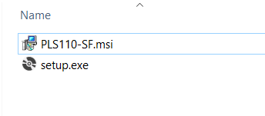

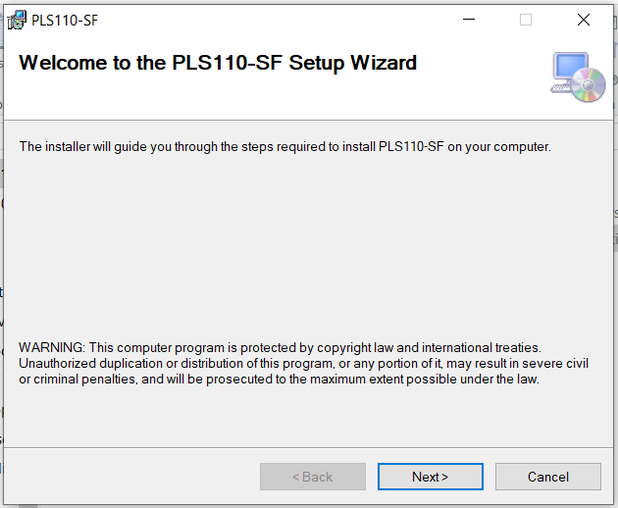

1. Select the desired folder path or keep as default path, also the User access to all or to the installer.

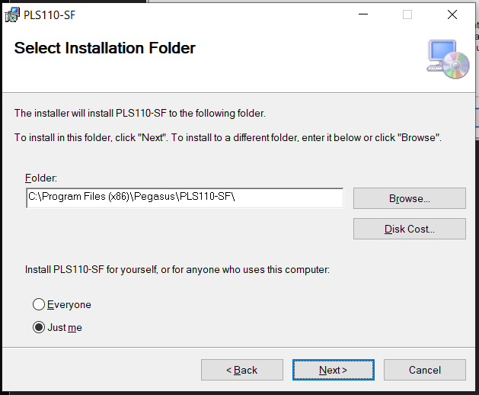

1. Start the installation by Clicking Next.

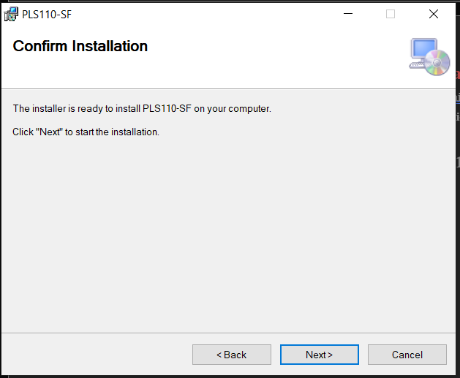

1. Once the Installation is completed click on Close to close the setup.

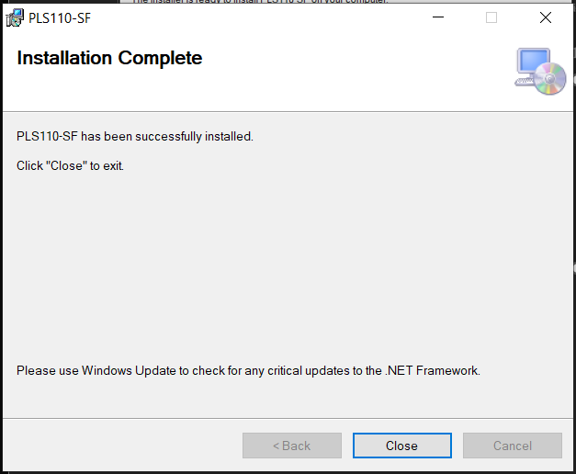

1. Once Setup is completed go to the folder where the Scale Middleware Application is installed, right click **PLS110-SF.exe** and select Properties option.

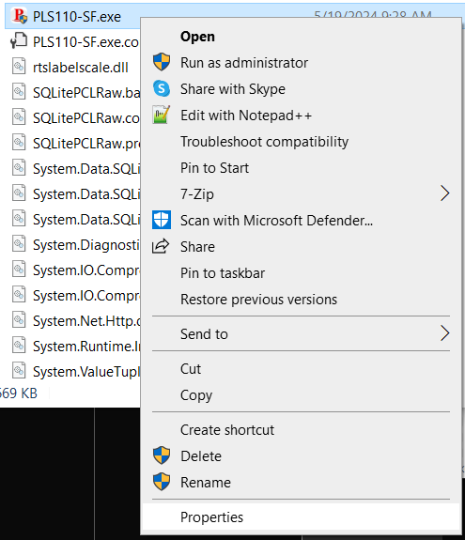

1. Select the Compatibility tab and check the **Run as Administrator** option as shown below to run the app in Admin Mode **(note: it is mandatory to run the app in Admin Mode)**.

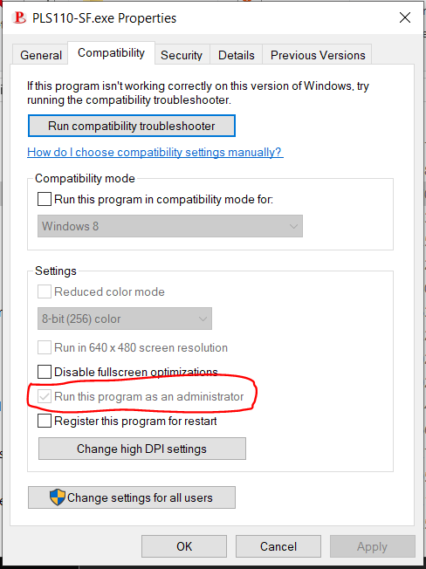

1. Go to the folder where the Scale Middleware Application is installed and you can run the application by double clicking **PLS110-SF.exe** and create a shortcut on desktop for the application by right clicking and selecting send to option and selecting desktop as shown below.

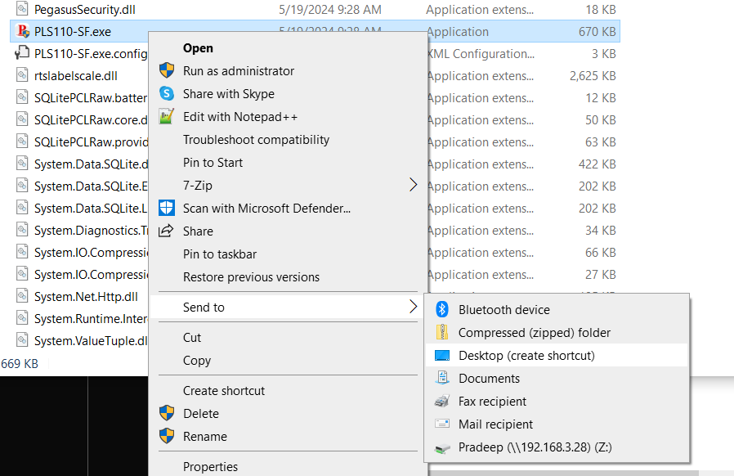

1. For Arabic text Support for the scale open Region Settings from Control Panel, go to Administrative tab and click on Change System Locale as shown below, Region window will appear, Select Arabic(‘Your Region’) from the Current System Locale drop down and then click ok and save.

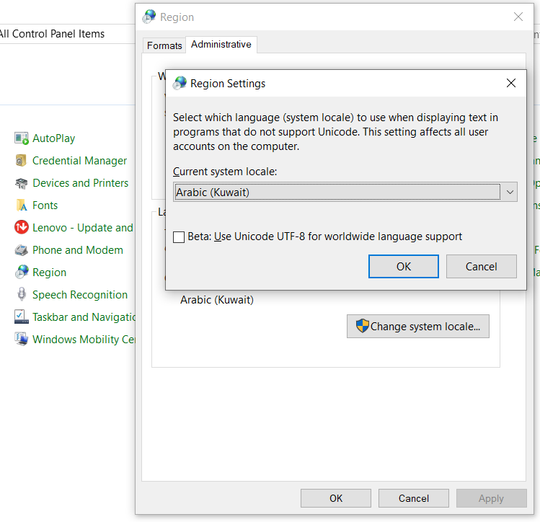

# License Activation

1. Before Loging in, user have to purchase the License for Scale Middleware Software.
2. After newly registration or verifying email account, purchasing the License, the user receives License Key through Email.
3. Run the Application, for the first time if not activated the license the Licensing Page appears where the user needs to enter the License Key and Click on Activate as below.

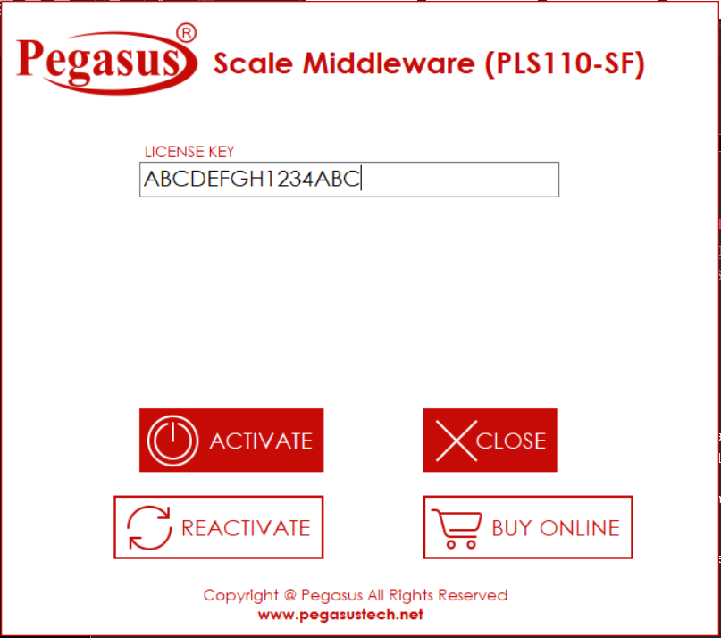

1. After the Activation is successful the Application will close and it will tell you to restart the Application as follows.

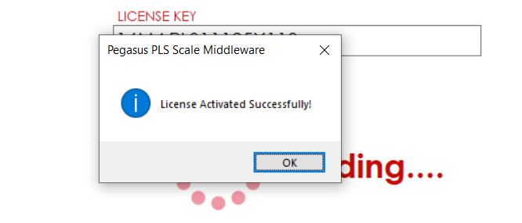

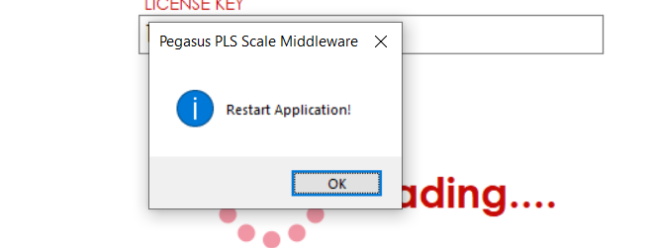

1. After restarting the Application Login screen will appear showing the credentials for login.

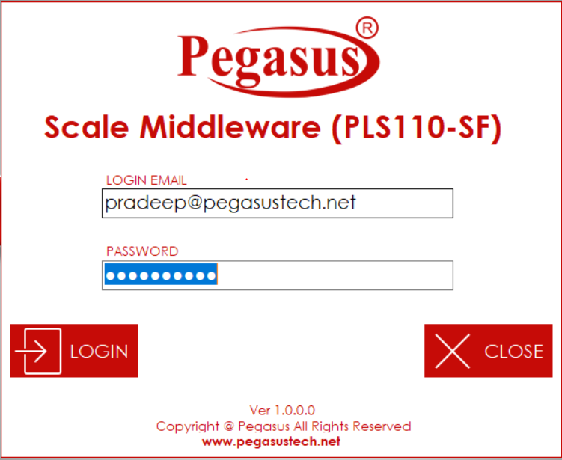

1. This credential is the same as used to register on Pegasus website, so use the same password to login.

# Main Screen and Options

After Loging in Main Screen is shown with all App Configuration Options.

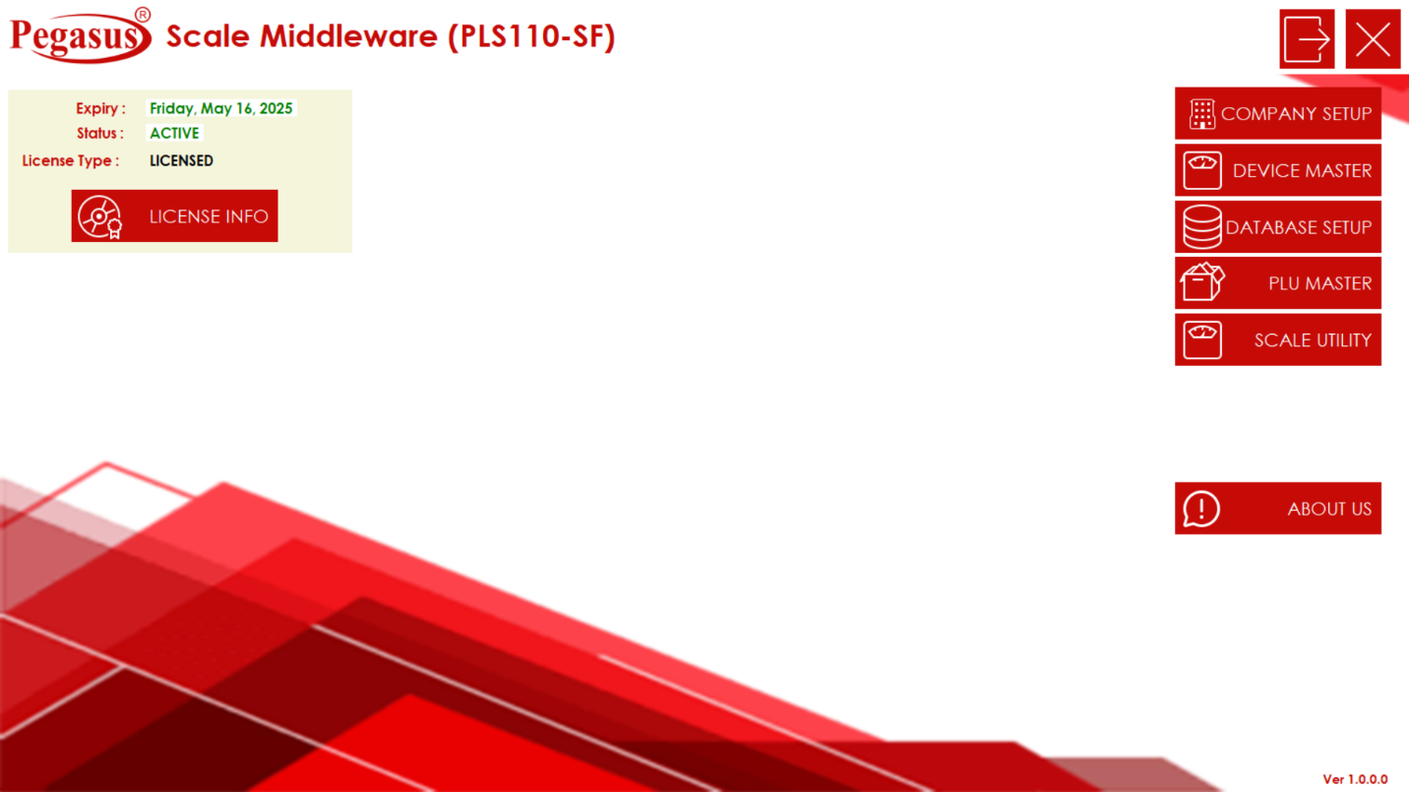

1. Company Setup Option shows the details of the company for which the License was purchased. It shows the all the necessary company details.
2. Device Master Option is to Configure all settings related to the Pegasus PLS1100 Scales.
3. Database Setup is for Configuring the Client Database for fetching the Scale Item information.
4. PLU Master Option is to check the List of PLU Items from the local as well as client Database.
5. Scale Utility is used to upload Item PLU’s to the Scales.
6. On the Left Top the Main Screen shows the License details and an option to Upgrade the License and reactivate.
7. About Us option shows the Pegasus Application Legal Policy.

# Company Master

1. Once you click on the Company Master option from Main Screen, Company Information page appears showing the Registered Company information as below.

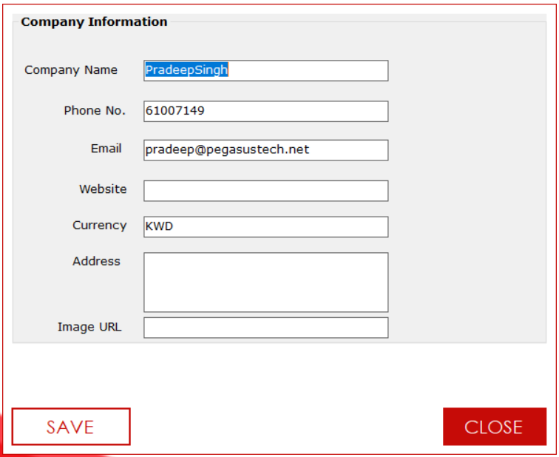

1. Click on close to close the Company Master Page.

# Device Master

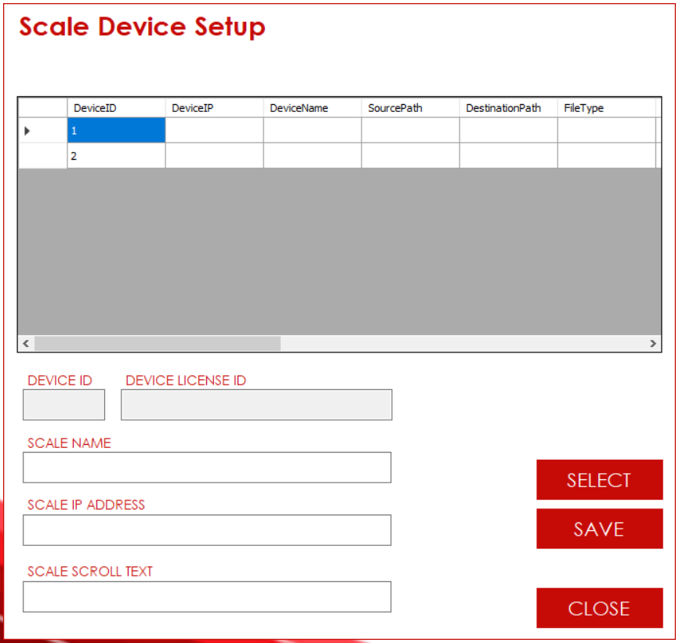

Device Master Shows the List of Total PLS1100 Scale devices for which the License was purchased. If more Scale needs to be added then one needs to upgrade the License.

1. Click on the Scale you want to configure and then click on SELECT.
2. It will Show the Detail of the selected Scale and then one can change and update them by Clicking on Save as below.

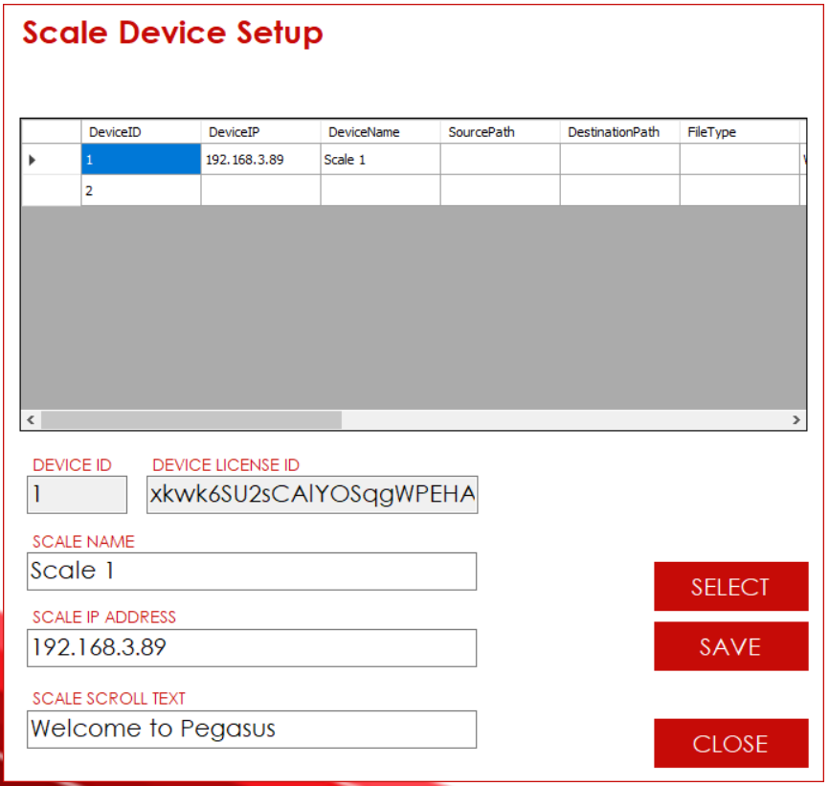

1. In scale Name one needs to enter an identifying name of the Scale.
2. In Scale IP Address, the IP address of the scale needs to be provided.
3. In Scale Scroll Text one needs to provide Header Message that will be displayed on scale Header.
4. Once all of the Device Parameters are entered click on SAVE to save the parameters for the scale.

# Database Setup

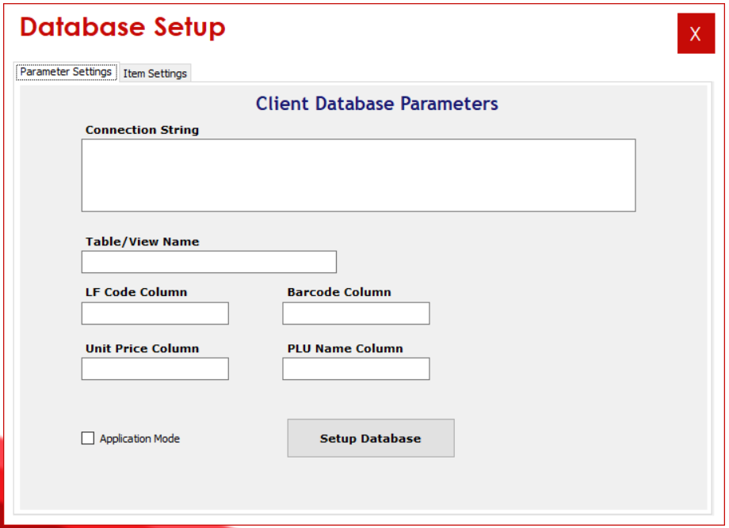

In Database Setup Form one needs to configure the Client Database Setup for fetching Item PLU’s.

1. Click on Setup Database Button, following Data Link Properties Form will appear where one needs to enter the Client DB Server credentials.

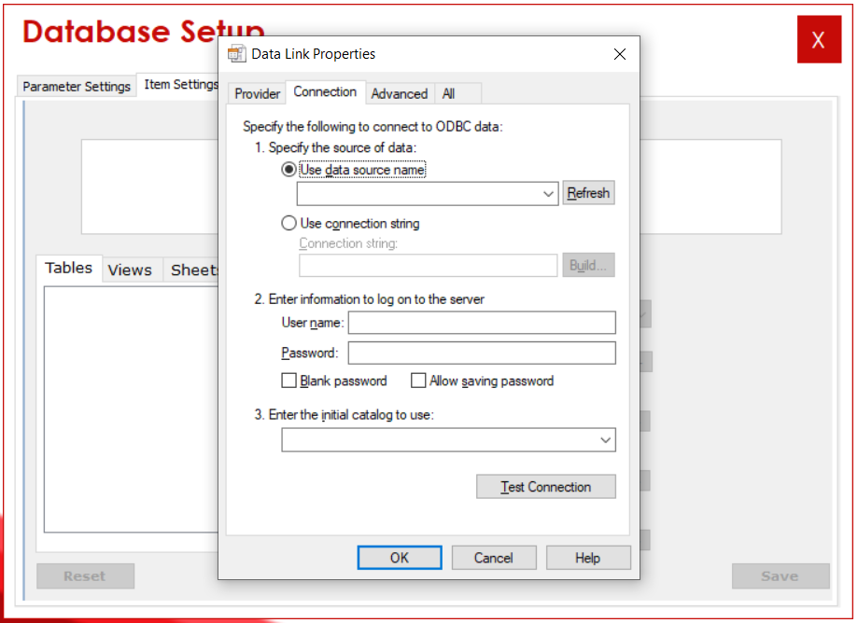

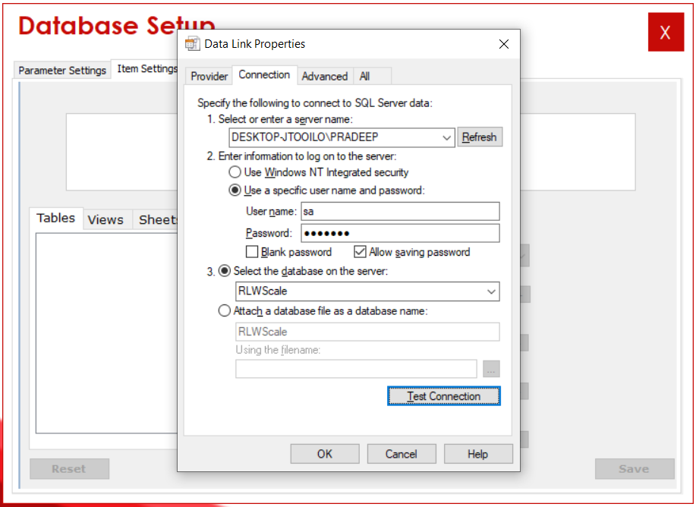

1. Once the credentials and all the database related details are entered and connection is tested successfully following Object Mapping form will appear.

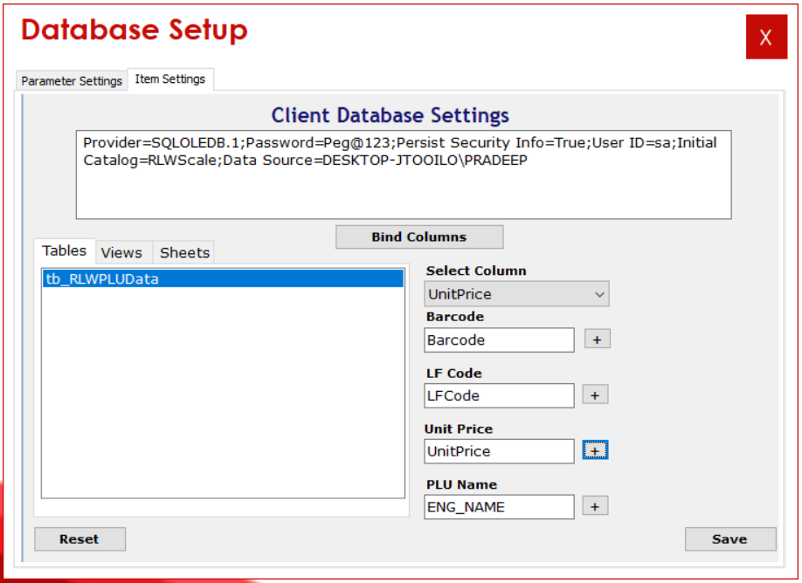

1. Select any Database object Listed in Table, View Tab and click on **Bind Columns** Button.
2. From the Select Column Dropdown list select the column needs to be mapped in Barcode Field and then click on the  button next to Barcode textbox to map the selected Column field to the Barcode Field.
3. Repeat the above step D. for the LF Code, Unit Price and PLU Name fields.
4. Once all the Fields are mapped Click on SAVE to save the Client Database Parameters.

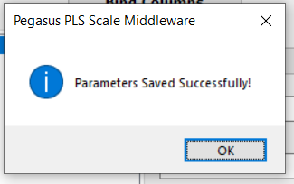

# PLU Master

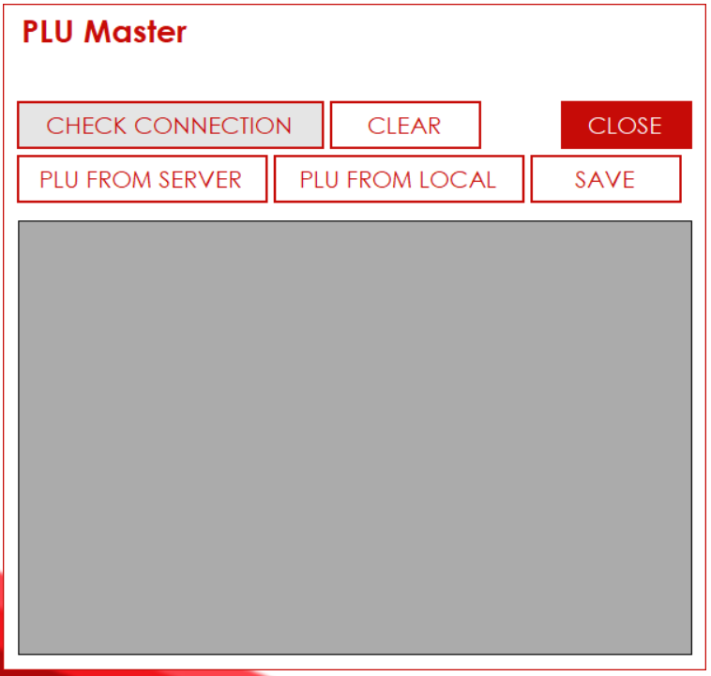

In PLU Master one can check the List of Item PLU’s from the Client Server DB and Local DB.

1. Click on **CHECK CONNECTION** to check connection with Client DB.
2. Once the connection is successful with the client DB, Click on the **PLU FROM SERVER** button to fetch PLU from Client Server DB.

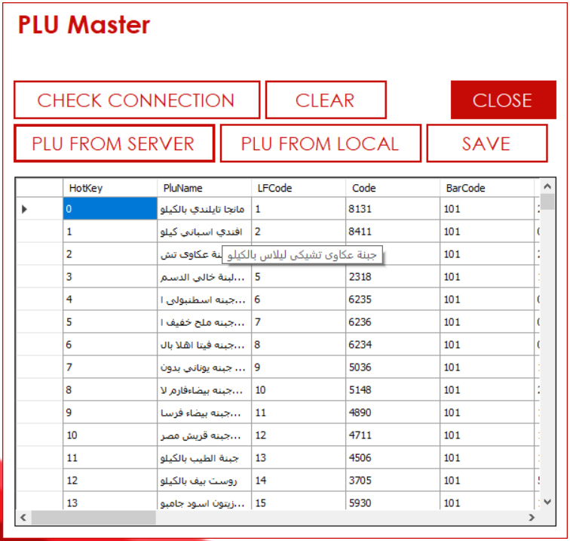

1. Click on the **PLU FROM LOCAL** button to fetch PLU from Local DB.
2. To save the PLU Fetched from Client DB to Local DB click on **SAVE** button.

# Scale Utility

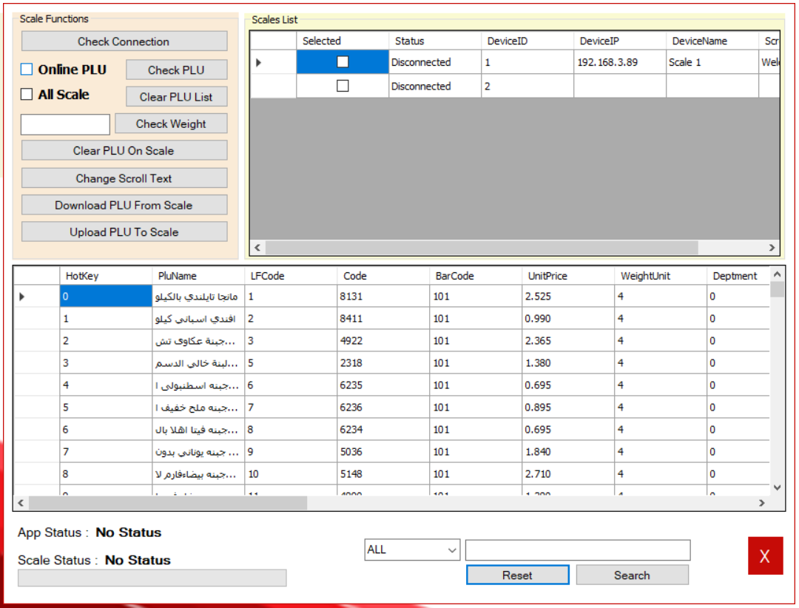

Scale Utility is the Utility to access Scale Device and PLU’s from Database.

1. **Online PLU** checkbox is checked and click on **Check PLU** button if the PLU needs to be fetched from Client Server DB, if from Local DB the uncheck.
2. If any Scale related Action needs to be performed on All Scales in the Scale List section, then check the **All Scale** checkbox else uncheck and select only the wanted Scale from Scale List section.
3. To check connection to the Scales, click on **Check Connection** button.

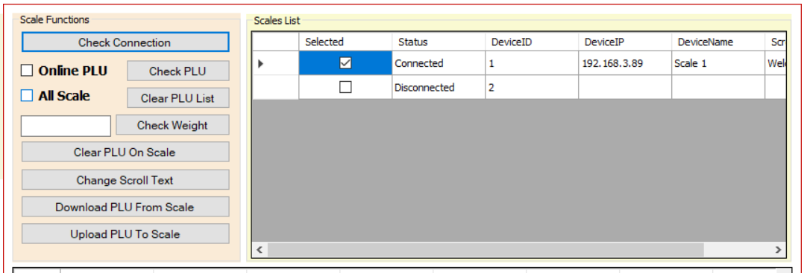

1. Once the connection is checked one can only select the connected Scales or connect the disconnected Scales.
2. To Clear the PLU on the Scale, click on the **Clear PLU On Scale** button, this will clear the PLUs on the scale.

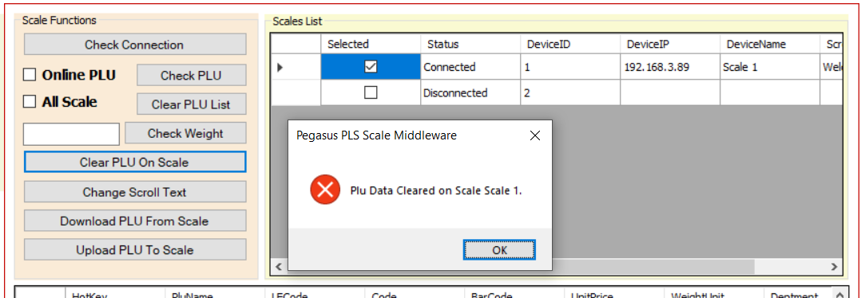

1. To Change the Header Scroll message on the Scale, click on the **Change Scroll Text** button, the header message configured on device master will be applied to the selected scales.
2. To upload the PLU List to the Scale, click on **Upload PLU To Scale** button, the PLUs list fetched from Client DB / Local DB will be Uploaded to the Scale.

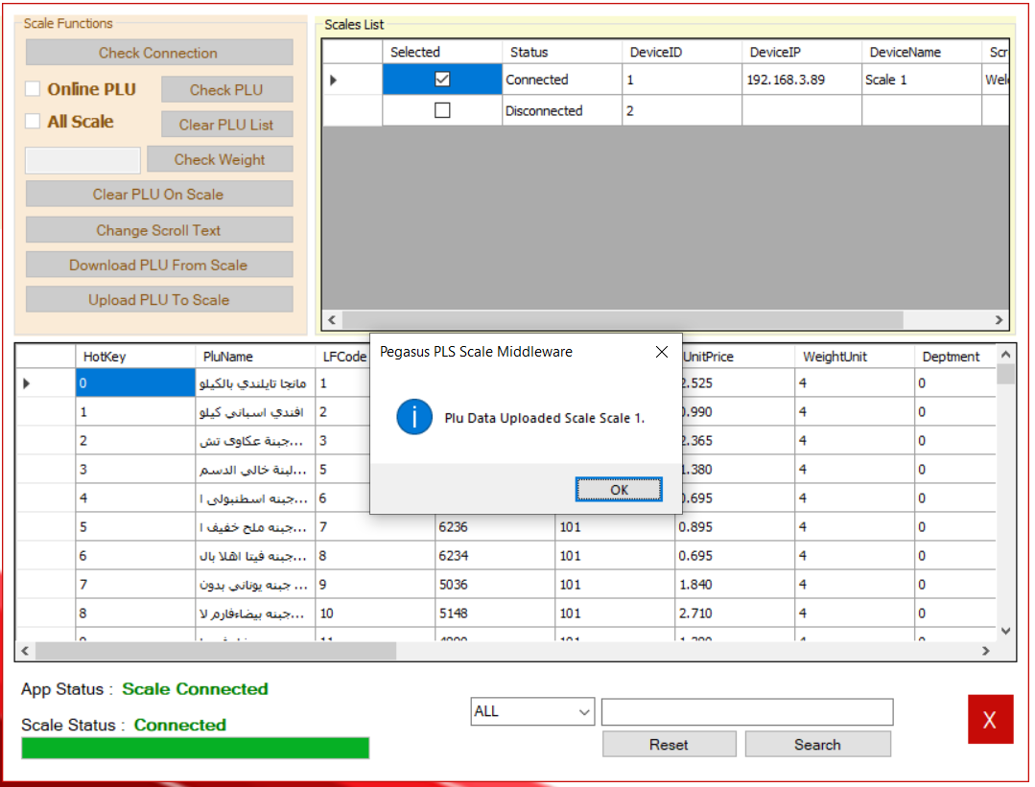

1. To Search PLUs in the list in bottom section of the Scale Utility form there are filters to search the PLUs.

# License Info

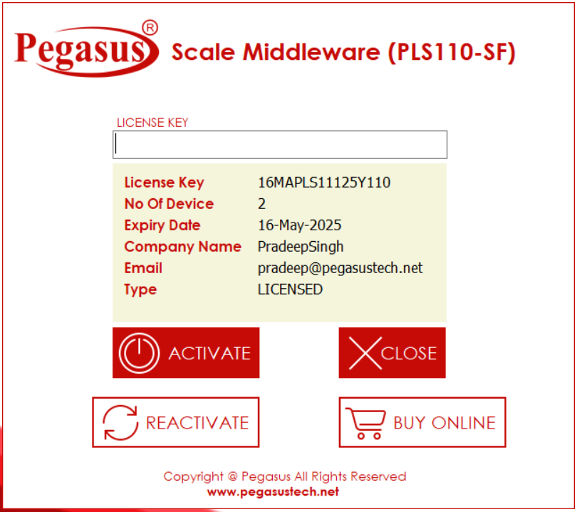

When one clicks on the **License Info** button on the Main page above page opens showing the License Information.

1. In case the License is expired or there is need of adding additional scale one needs to contact Pegasus and upgrade the License.
2. Once the License Upgrade confirmation is received then click on **REACTIVATE** button to reconfigure the license details
3. If the License is Expired then the application functions will be inactive.